MCB 5200

Cell Biology of the Mammalian Secretory Apparatus

3 Credits
Monday and Thursday 4- 5:30 PM.
Dr. Adam Zweifach

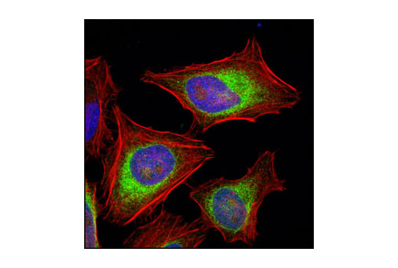
credit: CellSignal.com

An in-depth exploration of how cells synthesize secreted and transmembrane proteins and traffic them to their ultimate cellular destination. The class analyzes the classic papers that elucidated the system both for their scientific content and for the way the authors presented their evidence and arguments. Students will learn critical cell biology as well as a lot about how (and, just as importantly how not to) prepare figures and write papers.

