MCB 5255
Cellular and Molecular Immunology
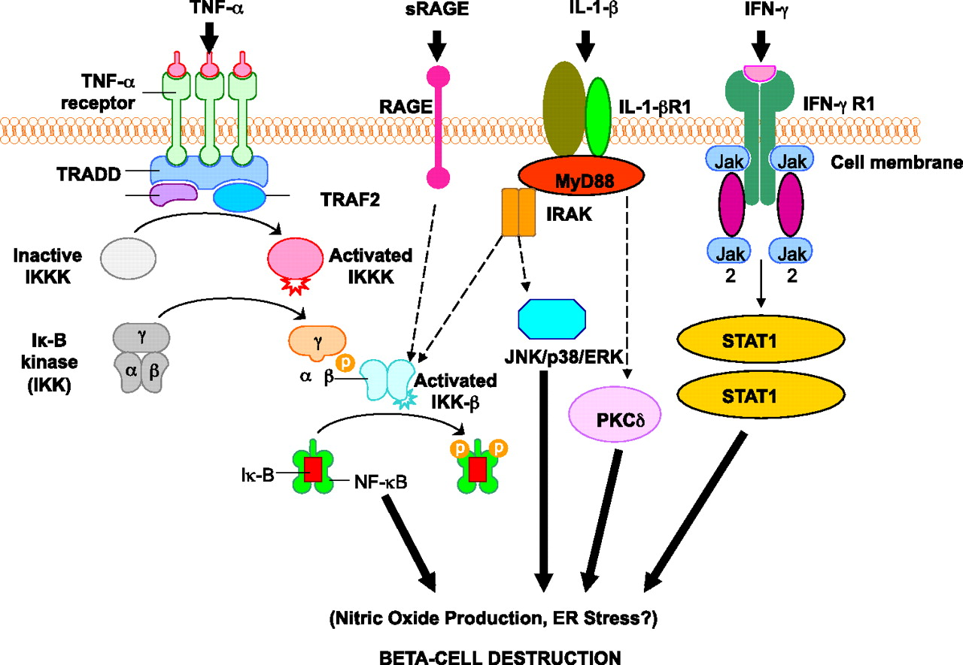

Inflammatory disease: Molecular mechanisms and therapeutic approaches to Type 1 Diabetes
Meeting times: Wednesdays 4-6 pm
Instructor: Michael Lynes
486-4350
michael.lynes@uconn.edu
This course will explore the genetic, biochemical, and cellular mechanisms that are central to disease-associated inflammation, the influences of chemical, biological and psychological stress on these mechanisms, and the therapeutic interventions that are possible.

Readings will be from the recent primary literature. Student participation will include both presentations, involvement in class discussions of the current literature, as well as the writing of an NIH-style grant proposal.
Permission number required, limited enrollment
About the course:
The course is NOT a lecture course. I present introductory lectures over the first month or so. From there, the course is a participatory: each student must give an hour-long presentation that provides the background and then discusses two current papers in the primary scientific literature on a relevant component of the overall topic. Students are graded on that presentation, on their participation in the discussions that ensue from other student presentations, and for the grant proposal that they write to propose a line of investigation related to their specific topic.

